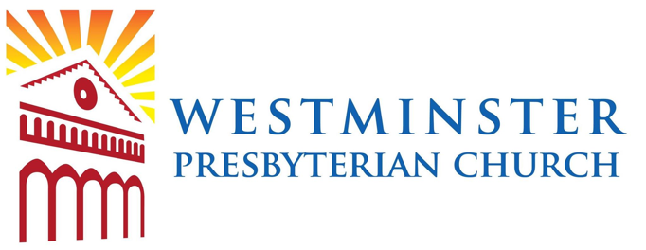
Summer Bible Blast
August 8-12, 2022 (Monday-Friday)
6:00 PM - 7:00 PM
Westminster Presbyterian Church SBB is the place to be for an extraordinary faith-based experience for the entire family to enjoy. Fun-filled programming will be available for the whole family including, children, youth and adults. The kids will experience interactive and meaningful bible stories with tons of interconnected creative crafts, fun games and an incredible service project to proclaim the love of Christ. The adults will participate in a separate study led by Rev. Bryan Franzen. Adults and children alike will join together in a family style meal, enjoy age appropriate breakout groups and close together with an intergenerational worship. Come gather with us for SBB, where God’s Word comes alive!

SPONSORED BY WESTMINSTER PRESBYTERIAN CHURCH
1100 SHASTA AVE.
SAN JOSE, CA 95126
(408) 294-7447
EMAIL: info@westpres-sj.com
www.westpres-sj.org

SBB REGISTRATION
August 8-12, 6:00-7:00 p.m.
Name:___________________________ADULT__CHILD/YOUTH__AGE___GRADE COMPLETED___
Name:___________________________ADULT__CHILD/YOUTH__AGE___GRADE COMPLETED___
Name:___________________________ADULT__CHILD/YOUTH__AGE___GRADE COMPLETED___
Name:___________________________ADULT__CHILD/YOUTH__AGE___GRADE COMPLETED___
Name:___________________________ADULT__CHILD/YOUTH__AGE___GRADE COMPLETED___
Address:____________________________________________City:____________________Zip:__________
Phone Number: (_______)________________Cell (_______)_________________Email________________
Church Affiliation:______________________How did you hear about us?___________________________
If a child/youth:
Parent/Guardian:_______________________________________________________________________
Who may pick up my child:_______________________________________________________________
I need childcare _____ (Ages: 0-3)
Medical Insurance:__________________________________________Policy #:_____________________
Food Allergies:_______________________________ Medications________________________________

MEDIA RELEASE
I hereby authorize Westminster Presbyterian Church (WPC) to take photos and videos during the event, which may later be used for marketing and promotional purposes. If you would not like yourself or your child appearing in any materials, please request in writing prior to the event.
CONSENT FOR EMERGENCY MEDICAL TREATMENT
In case of emergency, I understand that every effort will be made to contact me. If I cannot be reached, I hereby give the representative of WPC permission to act on my behalf to hospitalize, secure proper treatment and/or order an injection, anesthesia, or surgery for my child in the event that such treatment is deemed necessary by the physician, dentist, paramedic, EMT, or other skilled medical practitioner selected by the representatives of the WPC. I give permission to those administering emergency treatment to do so using those measures deemed necessary. I understand that I am signing for the minor listed on this form and my signature, as the parent or guardian of this minor, is consent for emergency medical treatment.
CONSENT TO PARTICIPATE
In planning and preparing for this event, WPC has carefully and methodically planned for a safe and successful event. However, no activity is without the possibility of hazards. Certain activities have inherent risks. Therefore, we want to alert parents, guardians and individuals to these risks. By signing this form, the parent, guardian and/or individual agrees to assume and accept all risks and hazards associated with its activity/event. These include, but are not limited to transportation to and from event location, transportation in and around the location of the scheduled activity/event, sports, health and safety hazards associated with sports activities and other unnamed and unspecified activities.
RELEASE OF LIABILITY (EXPRESSLY, SPECIFICALLY AND CONSPICUOUSLY INCLUDING NEGLIGENCE)
I further understand that BY signing below I AM FULLY AND FINALLY RELEASING WPC AND ALL ASSOCIATED PERSONS AND ENTITIES FROM ANY AND ALL claims and LIABILITY, EXPRESSLY INCLUDING BUT NOT LIMITED TO THEIR NEGLIGENCE, for any injuries, death, damages, or other losses that a participant may suffer or sustain in, before, during, or after events/activities contemplated in this document (or traveling to or from these events/activities).
This is a full and final release of any and all claims for injuries, damages and other losses of participant, expressly including claims for negligence of WPC agents, representatives, and employees.

The signature(s) below affirm our understanding of and agreement to abide by the statements herein. I/We agree with all statements, terms and conditions of the consent for emergency medical treatment and release of liability and consent to participate.

_____________________________________________________Participant or Parent/Guardian Signature Date Signed____/____/_____

